**Determination of the Firefly Luciferase mRNA Concentration and Encapsulation Efficiency in Nanoparticles Using RiboGreen Assay to Optimize Protein Carrier Gene Therapy**

**Background:**

mRNA has huge potential in therapeutic approaches to find the solution for infectious diseases, hereditary and acquired metabolic diseases, therapeutic cancer vaccination and protein replacement. As mRNA is a safer option because, unlike DNA, there is no risk of mutations in mRNA, mRNA is the most feasible and viable option for future gene therapeutics. To advance mRNA therapeutics and save lives from the threat of diseases and disorders, efficient delivery of mRNA into target cells is key. But the key question is how to identify the optimized delivery?

By using an optimization experiment, we can identify the best mRNA transfection reagents, and most importantly for the revolutionize delivery formats that can protect mRNA degradation from RNases to lead to efficient mRNA uptake and expression.

**Abstract:**

In the past decade, Messenger RNA (mRNA) has been used as a potent and powerful therapeutic in protein carrier gene therapy and is used for infectious diseases because of its safety advantages when compared to DNA (Kormann et. al). Novel delivery systems, such as lipid nanoparticles and reagents (ie. LFMM), are aimed at protecting the mRNA from degradation (Pardi et. al). To quantify mRNA and to find its encapsulation efficiency (EE%), RiboGreen reagent, a proprietary fluorescent RNA binding dye, was used for the detection and quantitation of RNA [Precision Nanosystems, Thermofisher Scientific]. The purpose of this study was to optimize a Ribogreen Assay for determination of Fluc mRNA Encapsulation Efficiency (EE%) in nanoparticles, including Lipofectamine Messenger Max (LFMM) and solid Lipid Nanoparticles (LNPs). The effects of assay conditions associated with detergent (Triton) extraction of the mRNA were analyzed. We found that increasing the volume of LFMM to weight of mRNA ratio from 1.5 to 6 ul/ug resulted in complete encapsulation of mRNA. Our initial ~25 % underestimate of free mRNA without LFMM (3.5 vs 4.7) was found to be due to poor replicates in the standard curve, and differing conditions in the sample vs standard (±OptiMEM, ±Triton). By using identical conditions in the sample and standard and ensuring duplicate repeatability (±5%), the 25% underestimate was reduced to 6%. The further influence of transfection reagent components needs to be completed

**Project Scope and the Social Impact:**

However, the success of mRNA depends on efficient delivery of mRNA and accurate measuring systems of concentrations of mRNA and each vector's respective encapsulation efficiency. In the past, cationic emulsions and modified liposomes have been unsuccessful. In addition, the optimal conditions for mRNA delivery were unknown. This project is significant to society and the medical industry as a whole because it identified the optimal delivery conditions for mRNA vectors, including volume to weight ratios, durations, and types of vectors, and found a novel and accurate method of measuring mRNA concentrations and encapsulation efficiencies. This project will be a game changer to society because not only does it maximize the efficiency of protein carrier gene therapy for all living organisms and consequently saves numerous lives, it also revolutionizes the medical and scientific field.

**Hypothesis/ Engineering:**

The research question is the determination and optimization of the concentration and Encapsulation Efficiencies of mRNAs in Lipid Nanoparticles (LNPs) and reagents (ie. Lipofectamine Messenger Max (LFMM)).

This is crucial because the success of mRNA delivery depends on efficient gene delivery systems with optimal conditions. Without successful mRNA delivery, mRNA-based therapeutics has a very limited scope. This objective relates to the reasons of choosing this project because it looks to optimize gene delivery by finding optimal vectors and conditions and optimizing mRNA experimental processes.

The research question tenets are:

1. What type of vector has the most successful encapsulation efficiency for mRNA?
2. What is the optimal condition for a successful mRNA delivery system?
3. What are the ideal ways to optimize the measurement systems crucial for determining the success of mRNA delivery systems?

**Materials:**

The major materials used include nuclease-free water, Ribogreen reagent, Fluc mRNA, LFMM and LNPs, and OptiMEM, Triton, sterile black plates, and 1xTE Buffer. The 1xTE Buffer, Triton Buffer, LNP sample, and LFMM sample was used in 50 µL sets. The Ribogreen solution was diluted to a 1:100 ratio.

**Procedure:**

First, 9 V/W (Volume / Weight) ratios were conducted. Second, the EE% (encapsulation Efficiency) and mRNA concentrations in two days were analyzed. Third, the quantitation of mRNA was optimized by fixing blanks, human error, and finding the interferents. The general procedure for setting up the assay that was used in each of the aforementioned 3 steps was to first prepare the samples of mRNA and vectors and add it to the first row with the 1xTE Buffer. Then, the first row contents plus additional 1xTE Buffer were added to the subsequent two rows. Then, these contents were mixed with Triton buffer and added to the following 2 rows. Finally, diluted Ribogreen was added and a fluoresence microplate reader were used to measure the concentrations of mRNA encapsulated.

**Data Analysis:**

**Analysis 1: Optimal Conditions for maximum Efficiency Analysis:**

First, to compare the effects of the volume to weight ratio on the encapsulation efficiency, there are 3 graphs. The first bar graph shows the encapsulation efficiencies variation between mRNA weights (ng) for LFMM nanocomplex. The second bar graph shows the comparison of encapsulated mRNA Concentration, Total mRNA Concentration, and encapsulation efficiencies of mRNA. The third line graph shows the mRNA 3 Standard Curve.

**Conclusion:**

The optimal volume to weight ratio was found and the trend line indicated that greater volume and lower weight lead to most optimized encapsulation efficiency. In addition, based on the type of mRNA, such as Trilink mRNA and DW mRNA, optimal volume to weight ratio for efficient delivery system differed significantly.

**Experiment 1: Commercial Reagent (LFMM) + mRNA Nanocomplex**

**Graph1**



**Graph2**

**Graph3**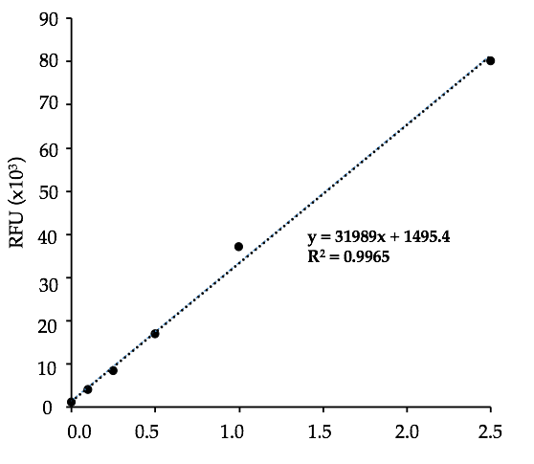

***Graphs 1,2, & 3:*** Graph 1 shows the EE% between mRNA weights (ng) for DW mRNA LFMM nanocomplex. Graph 2 shows the comparison of encapsulated mRNA Concentration, Total mRNA Concentration, and EE% of DW mRNA. Graph 3 shows the mRNA 3 Standard Curve.

**Analysis 2: Encapasulation efficiency comparison to identify the optimal vector**

Second, to look at the differences between the encapsulation efficiencies in different vectors, 2 bar graphs would be used. One would show the variation in encapsulation efficiencies, total mRNA Concentrations, and observed encapsulated mRNA concentrations between two different lipid nanoparticles and the comparison with the vector reagent Lipofectamine Messenger Max. Another would show the variation between different vectors, lipid nanoparticles and Lipofectamine Messenger Max, over durations of time.

**Experiment 2: Interfering Substances (ie. Triton & Optimum)**

**Graph4**



**Graph5: Graph6:**

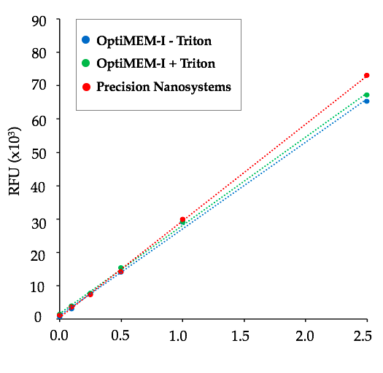 

**Graph 7:**

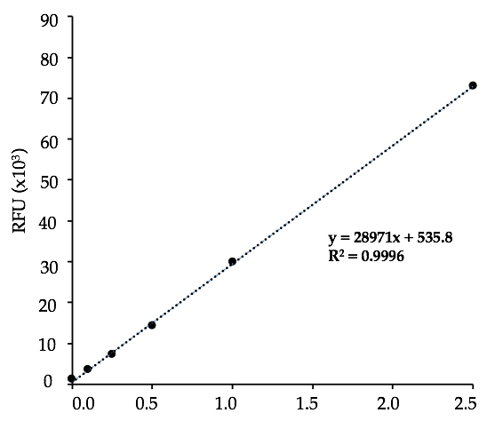

***Graphs 4,5,6,& 7:*** Graph 4 shows the mRNA Conc. between expected and with/without Triton. Graph 5 shows the standard curves between OptiMEM-I with/without Triton and Precision Standard Curve. Graph 6 shows the mRNA Conc. Between expected and with/without Triton. Graph 7 shows the mRNA 4 curve.

**Conclusion:**

LFMM, and similar liquid reagents, proved to be better than lipid nanoparticles and other solid vectors in encapsulating the mRNA. In addition, there was a optimal duration period for LFMM and lipid nanoparticles in which encapsulation efficiency was satisfactory for a successful delivery system.

**Analysis 3: Optimizing the accuracy of measurement that are crucial for determining the ideal delivery system:**

Third, to look at the effect of interfering substances, such as Triton and OptiMEM-I, 4 graphs would be used. The first graphs shows the mRNA Conc. between expected and with/without Triton. The second graph shows the standard curves between OptiMEM-I with/without Triton and Precision Standard Curve. The third graph shows themRNA Conc. Between expected and with/without Triton. The fourth graph shows the mRNA 4 curve.

**Conclusion:**

Measurement systems used currently, in reality, contain harmful substances, such as Triton and OptiMEM-I, that interfere with results. A novel measurement system identified these two interferents and created a measurement system in which the buffer concentrations were altered and copious amounts of Triton and OptiMEM-I were removed to get better accuracy in results.

**Graph 8: Graph9:** 

***Graphs 8 & 9:* Graph 8 (Bar Graph) shows the EE% of Trilink Fluc LNP and DW Fluc LNP between two different days. Graph 9 (Bar Graph) shows the observed total mRNA concentration and encapsulated mRNA concentration between Trilink Fluc LNP and DW Fluc LNP between two different days.**

**Summary:**

This project found the optimal conditions, in terms of volume to weight ratios, durations of time, and the type of vectors, that would lead to the most efficient mRNA delivery systems. In addition, it made a novel measurement system and identified interferents that altered the accuracy of the data. By achieving these goals, this project is a one more step in the right direction to  revolutionizes the gene delivery systems, which are critical for protein carrier gene therapy and crucial for saving not only lives in our society, but also revolutionizing the medical and science fields.

**Conclusions:**

The optimal volume to weight ratio was found and the trend line indicated that greater volume and lower weight lead to most optimized encapsulation efficiency. In addition, based on the type of mRNA, such as Trilink mRNA and DW mRNA, optimal volume to weight ratio for efficient delivery system differed significantly.

LFMM, and similar liquid reagents, proved to be better than lipid nanoparticles and other solid vectors in encapsulating the mRNA. In addition, there was a optimal duration period for LFMM and lipid nanoparticles in which encapsulation efficiency was satisfactory for a successful delivery system.

Measurement systems used currently, in reality, contain harmful substances, such as Triton and OptiMEM-I, that interfere with results. A novel measurement system identified these two interferents and created a measurement system in which the buffer concentrations were altered and copious amounts of Triton and OptiMEM-I were removed to get better accuracy in results.

This project found the optimal conditions, in terms of volume to weight ratios, durations of time, and the type of vectors, that would lead to the most efficient mRNA delivery systems. In addition, it made a novel measurement system and identified interferents that altered the accuracy of the data. By achieving these goals, this project is a one more step in the right direction to  revolutionizes the gene delivery systems, which are critical for protein carrier gene therapy and crucial for saving not only lives in our society, but also revolutionizing the medical and science fields.

**Bibliography:**

Benke, Erik Oude. “Intracellular Delivery of RNA Therapeutics with Lipid Nanoparticles.” Pharmaceutical Sciences.

Jones LJ1, Yue ST, Cheung CY, Singer VL. “RNA quantitation by fluorescence-based solution assay: RiboGreen reagent characterization. Anal Biochem. 1998 Dec 15;265(2):368-74.

RiboGreen Assay: Revision 003, Document ID: PNI-SOP-S9-001-EXT

Weissman, Drew. “MRNA Transcript Therapy.” Expert Review of Vaccines 14, no. 2 (February 2015): 265–81.

Al-Dosari, Mohammed S., and Xiang Gao. “Nonviral Gene Delivery: Principle, Limitations, and Recent Progress.” The AAPS Journal 11, no. 4 (December 2009).

Sahin, Ugur, Katalin Karikó, and Özlem Türeci. “MRNA-Based Therapeutics — Developing a New Class of Drugs.” Nature Reviews Drug Discovery 13, no. 10 (October 2014): 759–80.

**Acknowledgements:**

* Thanks to Dr. Michael D. Buschmann, Dr. W. W. Shanaka I. Rodrigo, Mr. Manuel Carrasco from Department of Bioengineering, George Mason University Institute of Advanced Biomedical Research, Manassas VA for guiding and mentoring me on this project work
* Thanks to my teachers Ms. Holman, Ms. McAleer from Thomas Jefferson High School for Science and Technology, Alexandria VA, for their guidance and mentorship